**Assignment: 2 Python_Basics**

Name: Harsh M. Mekhiya   
email: [harshmekhiya191@gmail.com](mailto:harshmekhiya191@gmail.com)

**Tasks**

**1. Grade Checker**

**Take a score as input and print the grade based on the following:**

**90+ : "A"**

**80-89 : "B"**

**70-79 : "C"**

**60-69 : "D"**

**Below 60 : "F"**

**here we used a basic if else statement to carry out marks and all.**

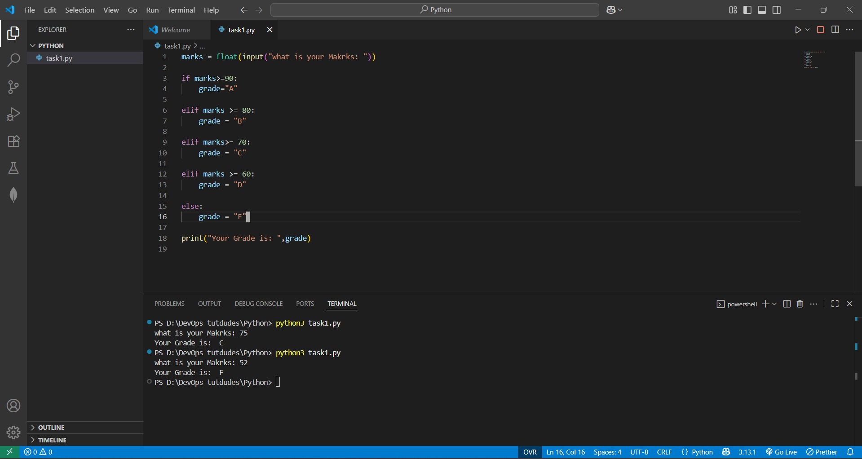

Explanation:

In this task, I made a small program where the user enters a score, and the program tells which grade it belongs to. I used simple if–else conditions to check the score range. For example, if marks are above 90 it shows grade A, if marks are between 80 and 89 it shows grade B, and so on. If marks are less than 60 then it shows grade F.  
This program is useful to understand how conditions work in Python and how we can check different cases step by step.

**Tasks**

**2 Student Grades**

**Create a dictionary where the keys are student names and the values are their grades. Allow the user to:**

**Add a new student and grade.**

**Update an existing student’s grade.**

**Print all student grades.**

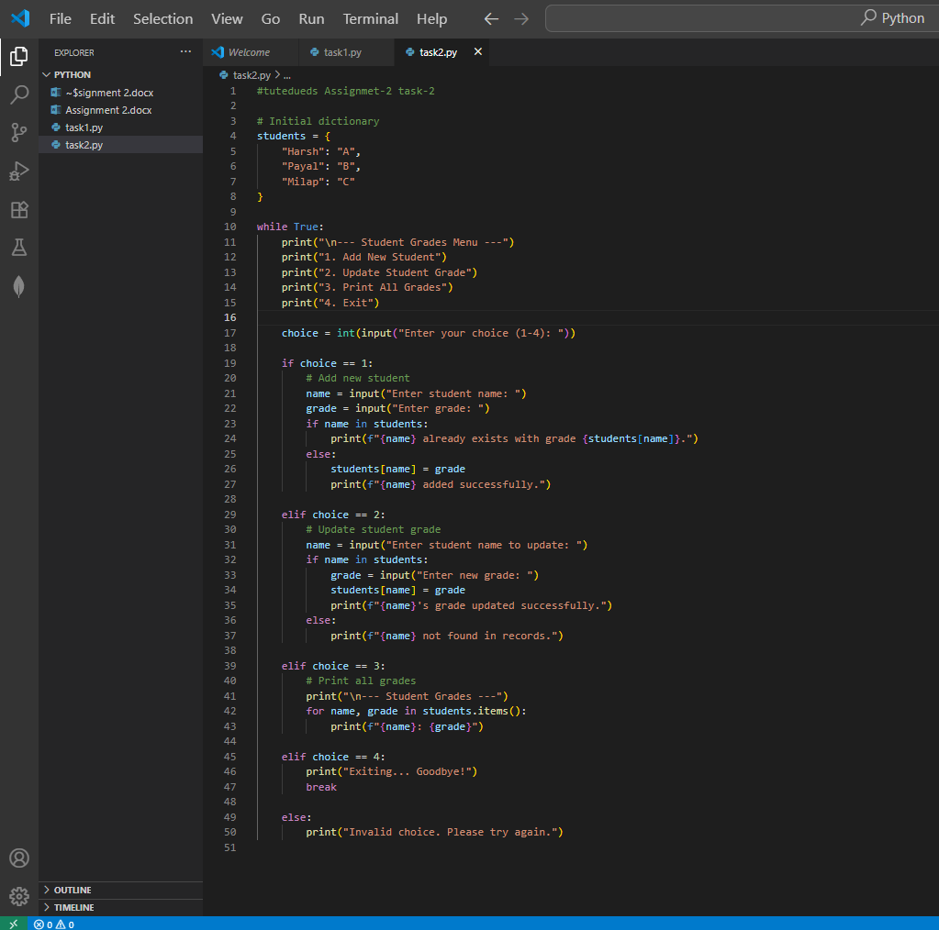

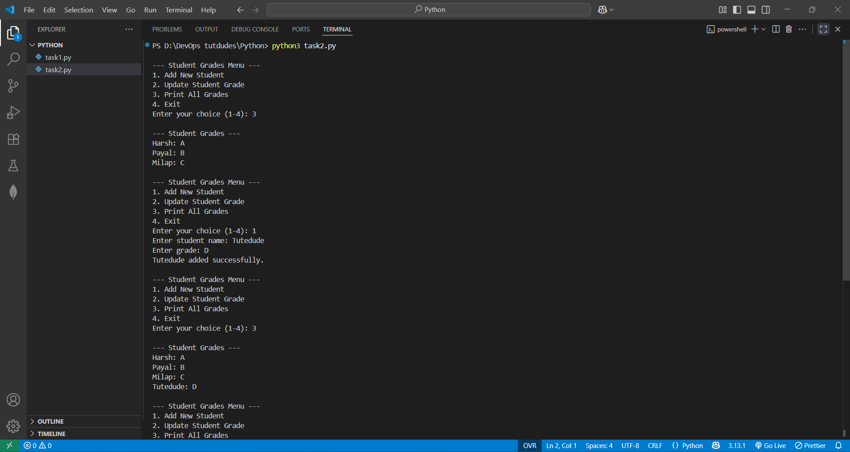

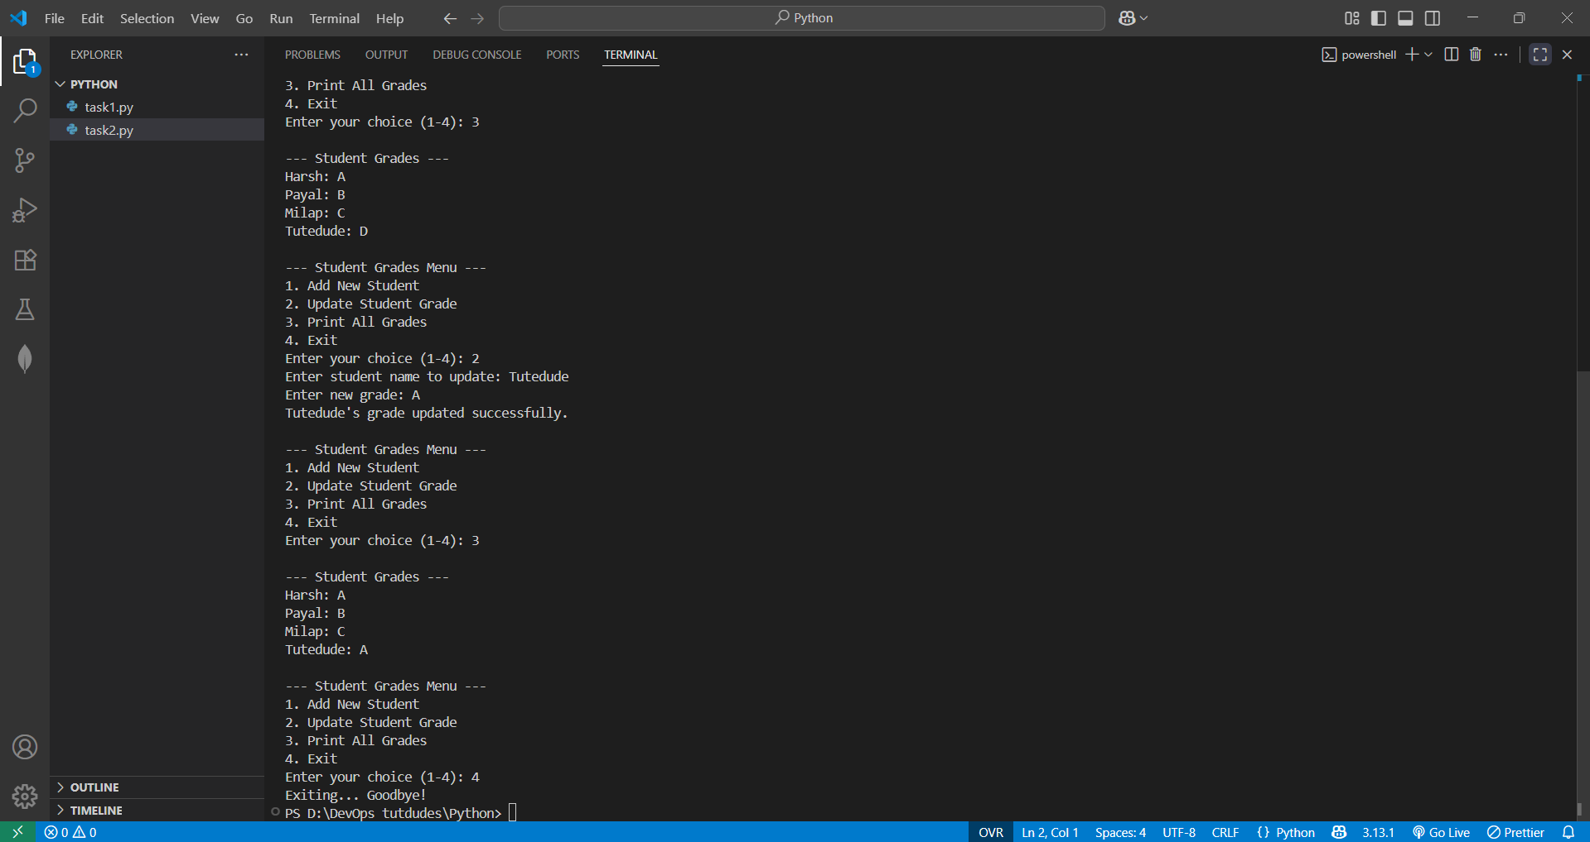

Explanation:

In this program, I used a dictionary to store students’ names and their grades. The idea is that the name is the key and the grade is the value. I created a small menu where the user can choose what they want to do: add a new student, update someone’s grade, see all students’ grades, or exit. The loop keeps running until the user exits.  
Through this, I understood how dictionaries are helpful for storing data like name–grade pairs, and how to add, update, and print data. It also gave practice of using loops and if–else in a real-like program.

**Tasks**

**3.Write to a File**

**Write a program to create a text file and write some content to it.**

**Using file functions like write and open.**

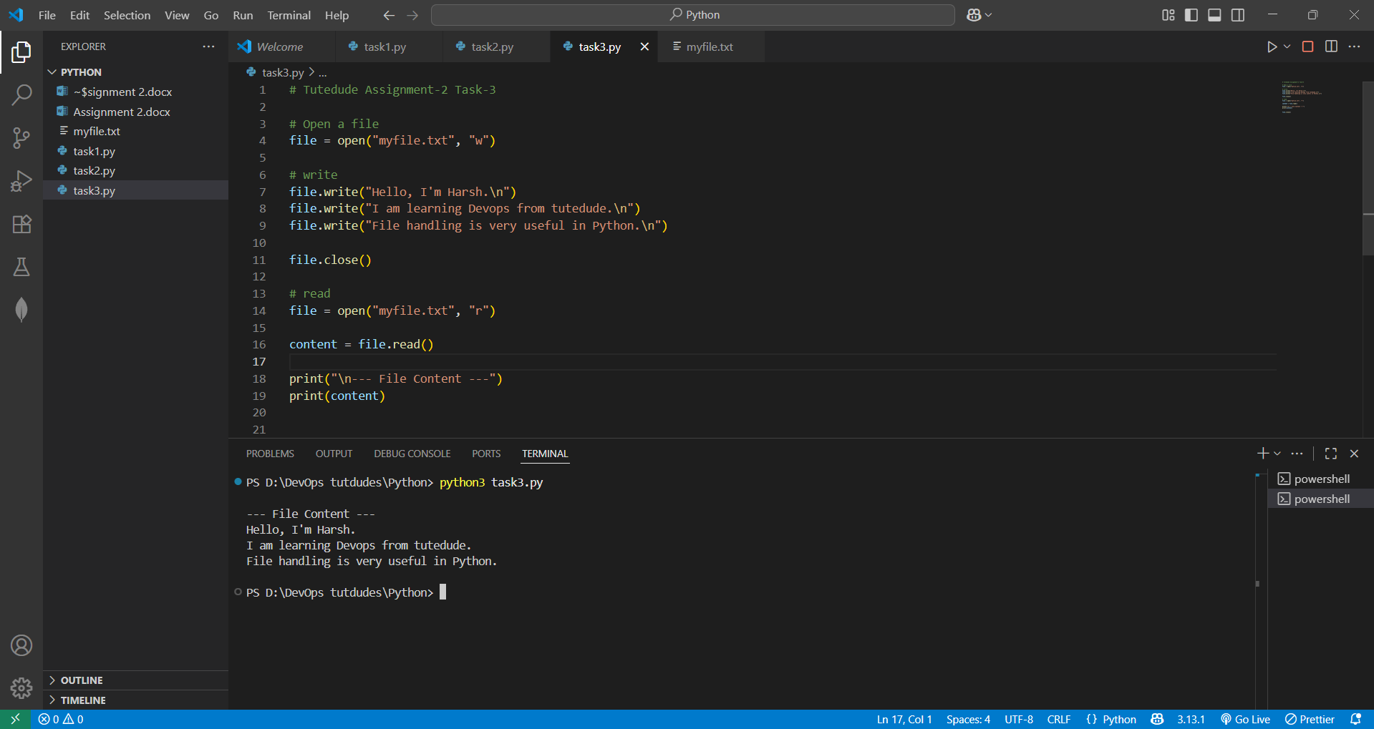

Explanation:

In this task, we practiced how to create and write to a text file in Python. The file was first opened in **write mode ("w")** using the open() function. Then, the write() method was used to add multiple lines of text into the file. After writing, the file was closed with the close() method to ensure that all the content was properly saved. To verify the written content, the file was later reopened in **read mode ("r")**, and the read() method was used to display everything stored inside the file. This task shows how Python allows us to create, store, and view data in text files.

**Tasks**

**4. Read from a File**

**We used open in read mode and file.read to read and print to display.**

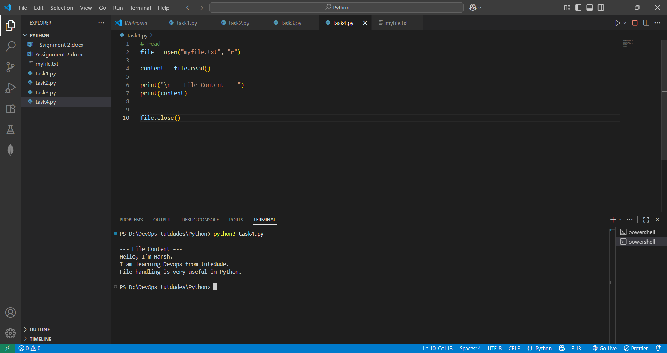

Explanation:

In this task, we learned how to read the content of a file using Python. First, the file was opened in **read mode ("r")** with the open() function. Then the read() method was used to fetch the entire content of the file and store it in a variable. After that, the program displayed the content on the screen using print(). Finally, the file was closed with the close() method to free system resources. This task shows how Python can easily access and display stored information from a text file.